**MATHEMATICS SPECIALIST UNIT 3&4 Name_______________**

**TEST 5, 2017**

You must show all working

**Section One: Resource Free**

Reading time: 2 minutes Time: 18 minutes Total marks: 18 ________________________________________________________________________________________

**Question 1 (4 marks)**

Determine a general solution for 

**Question 2 (4 marks)**

Solve  if  at **Question 3 (3 marks)**

The differential equation $y^{'}=\frac{2x}{y}$ is shown in just one of the four slope fields below.

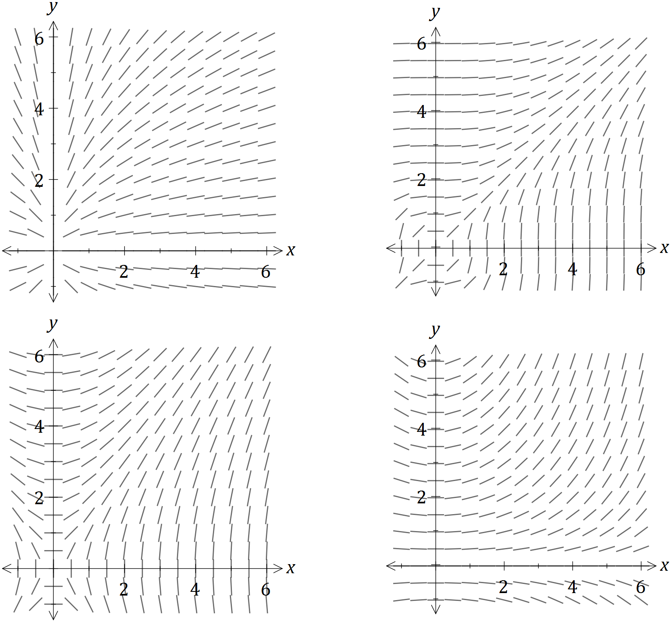

On the slope field for $y^{'}=\frac{2x}{y}$, sketch the solution of the differential equation that passes through the point $(2, 4)$.

**Question 4 (3 marks)**

A cube of side x is slowly increasing.

Use a calculus method to determine the increase in the surface area of the cube as  increases from 10 to 10.1 cm.

Question 5 (4 marks)

A floating pontoon at a tidal marina is connected to the top of the harbour wall by a hinged walkway AB of length 13 metres.



When the top of the pontoon, B, is 5 m below the top of the wall, A, the sea is rising at a rate of 2 cm per minute.

At this instant, calculate the rate at which the barge is moving away from the wall.

**MATHEMATICS SPECIALIST UNIT 3&4 Name_______________**

**TEST 5, 2017**

You must show all working

**Section One: Resource Rich**

Reading time: 2 minutes Time: 30 minutes Total marks: 30 ________________________________________________________________________________________

Question 6 (13 marks)

(a) Show that the gradient of the curve $2x^{2}+y^{2}=3xy$ at the point $(1, 2)$ is $2$. (3 marks)

(b) Another curve passing through the point $\left(-2, 10\right)$ has gradient given by $\frac{dy}{dx}=\frac{2xy}{1+x^{2}}$.

Use a method involving separation of variables and integration to determine the equation of the curve. (4 marks)

(c) A particle is moving along the curve given by $y=\sqrt[3]{x}$, with one unit on both axes equal to one centimetre. When $x=1$, the y-coordinate of the position of the particle is increasing at the rate of 2 centimetres per second.

(i) Show that the x-coordinate is increasing at 6 centimetres per second at this instant.

(2 marks)

(ii) Determine the exact rate at which the distance of the particle from the origin is changing at this instant. (4 marks)

**Question 7 (5 marks)**

Some technetium-99m produced at 9 a.m. had an activity of 20 units. By 10 a.m. it had decreased to 18 units. An activity of over 7 units is need for it to be useful for radiation therapy. Given that the activity decreases according to ,

find the time that it ceases to be useful.

**Question 8 (7 marks)**

The number of deaths from Avian (bird) Influenza in Cambodia was reported to the World Health Organisation (WHO).

Over the years 2010-2015 the number of deaths from Avian Influenza can be

determined by the equation  where  is in years where 

(a) Determine the number of deaths in Cambodia from Avian Influenza in 2012. (1 mark)

(b) (i) Find the rate of increase of cases of Avian Influenza in 2015. (2 marks)

(ii) Is the number of cases increasing or decreasing in 2013? (2 marks)

(c) Sketch the shape of the curve (2 marks)

**Question 9 (5 marks)**

Consider the direction graph below.

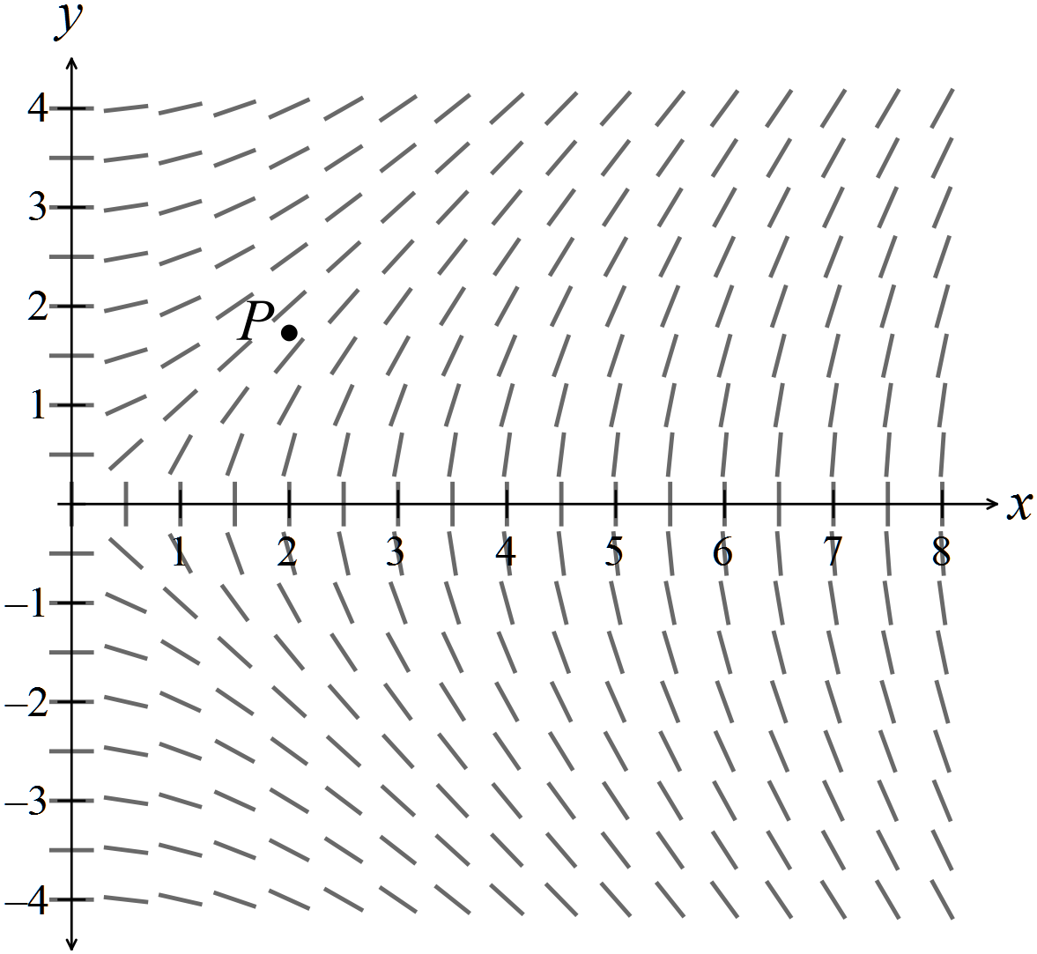

(a) Use the direction graph to help you sketch the solution curve, that passes through the point  (2 marks)

(b) Comment on the shape of the slope field that passes through the point  as  goes from -4 to 4. (3 marks) (2)

(1)